Operations on Emp database

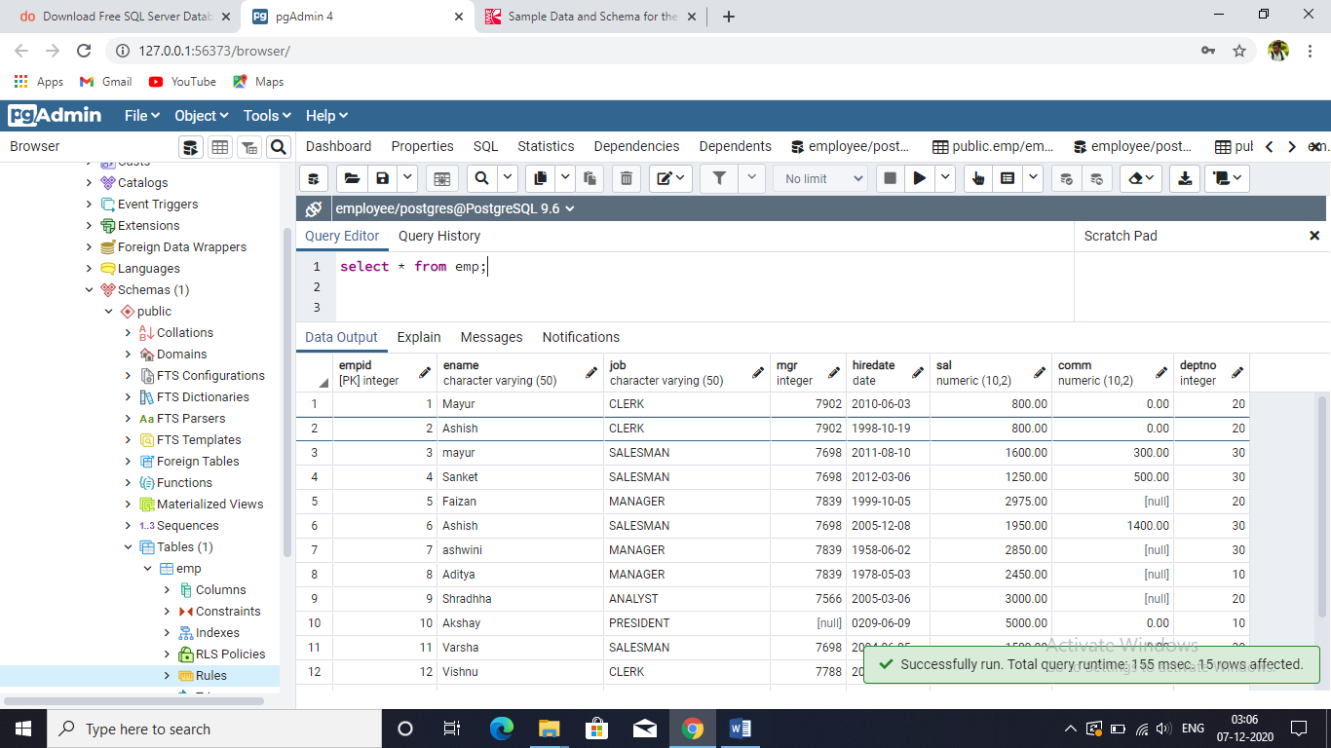

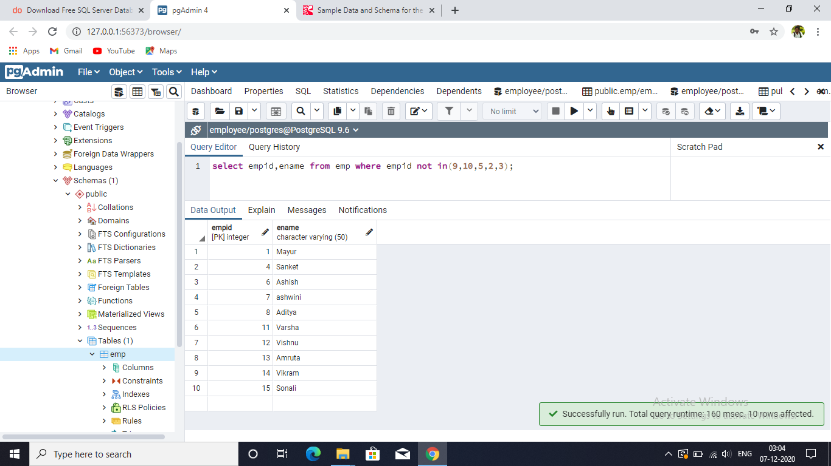select empid,ename from emp where empid not in(9,10,5,2,3);

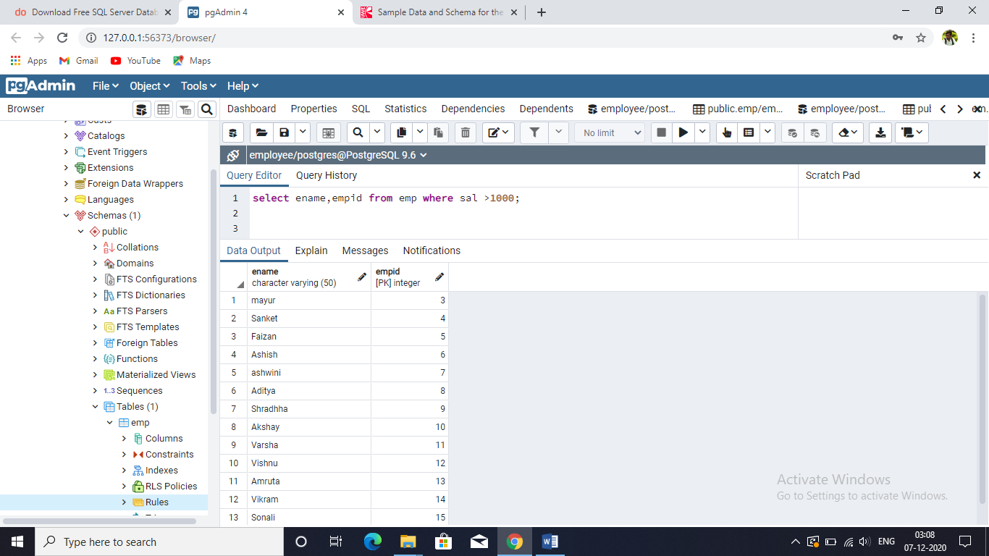select ename,empid from emp where sal >1000;

select empid,ename from emp order by empid limit 5;

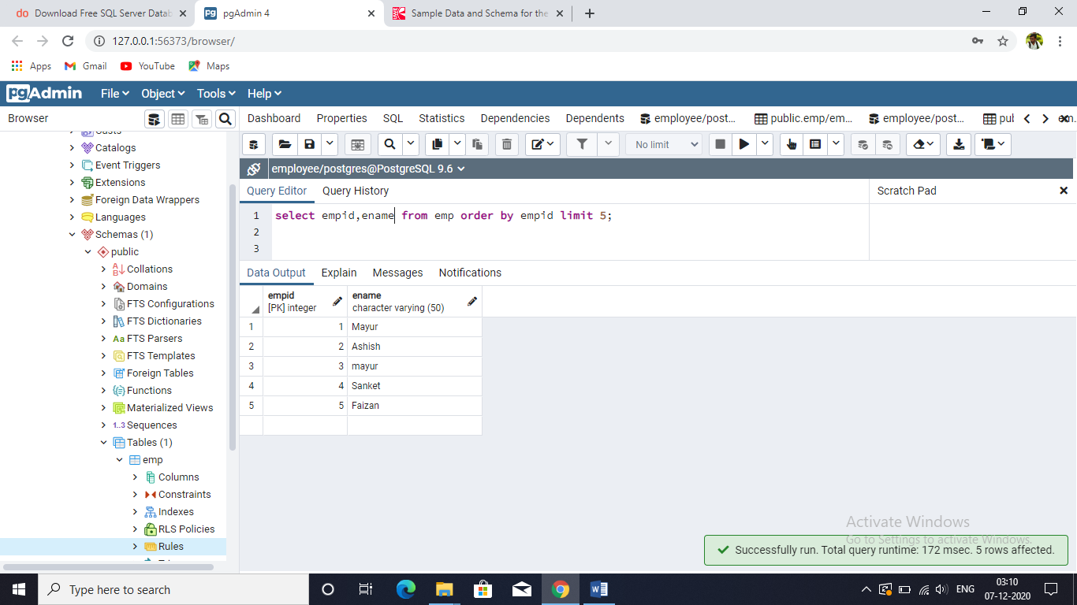

select empid,ename from emp order by empid offset 3 limit 5;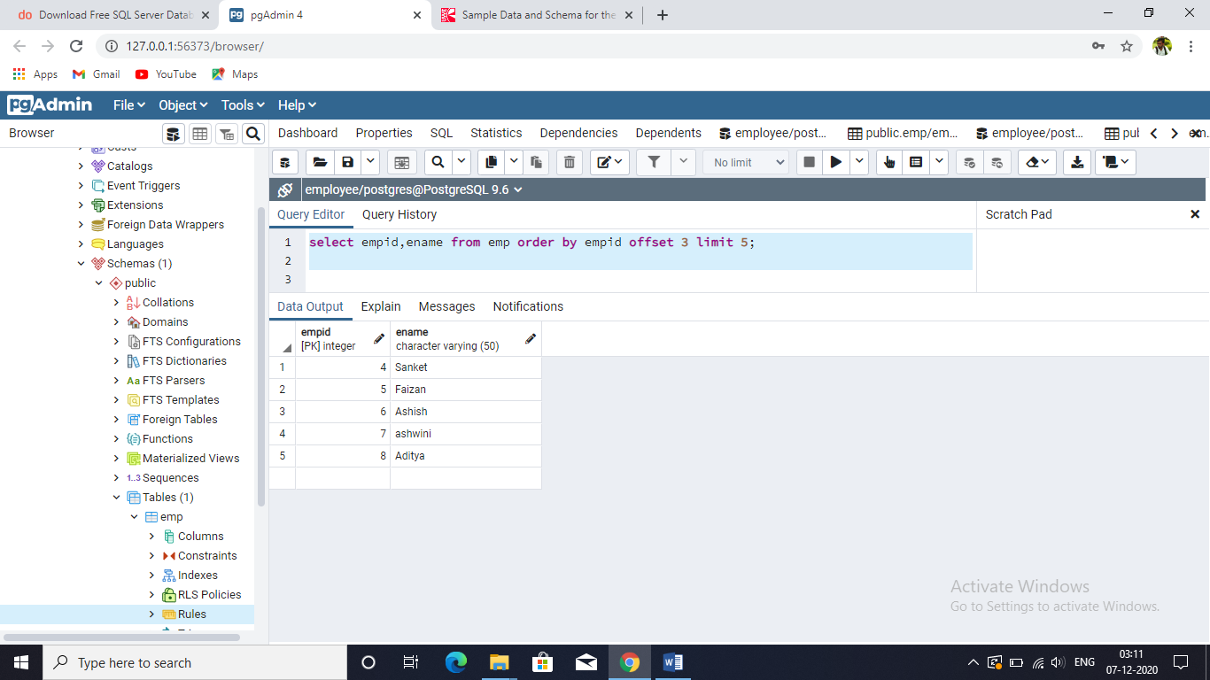

select empid,ename from emp order by empid DESC offset 3 limit 5 ; 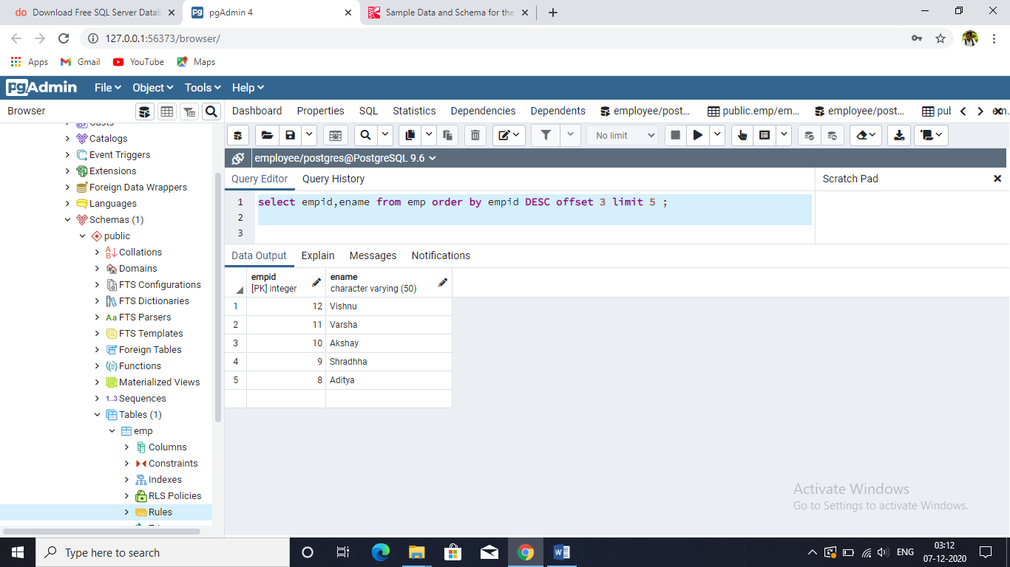

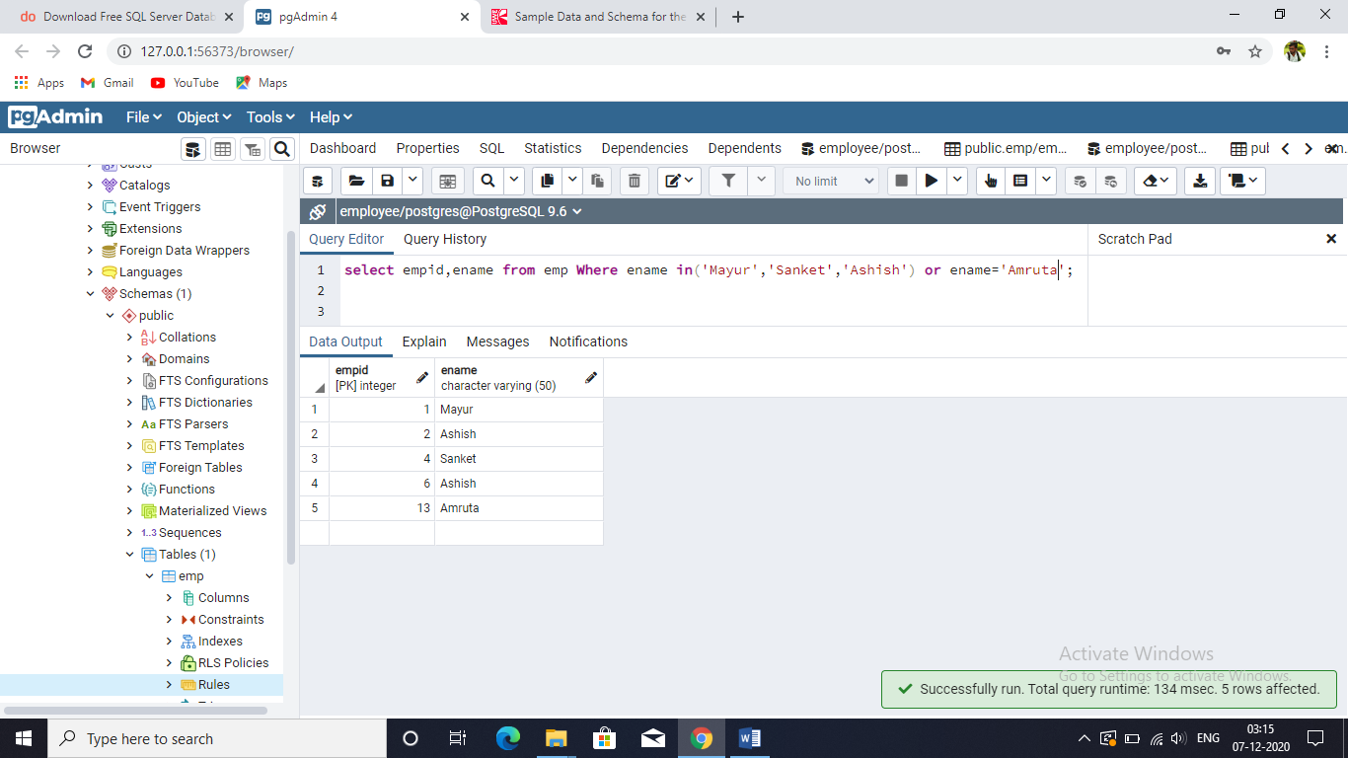select empid,ename from emp Where ename in('Mayur','Sanket','Ashish') or ename='Amruta';

SELECT empid, ename FROM emp ORDER BY empid FETCH FIRST 8 ROW ONLY;

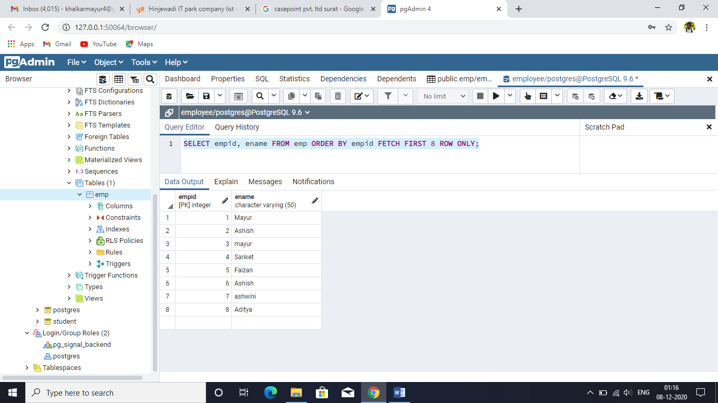

SELECT empid,ename FROM emp WHERE empid <> 3;

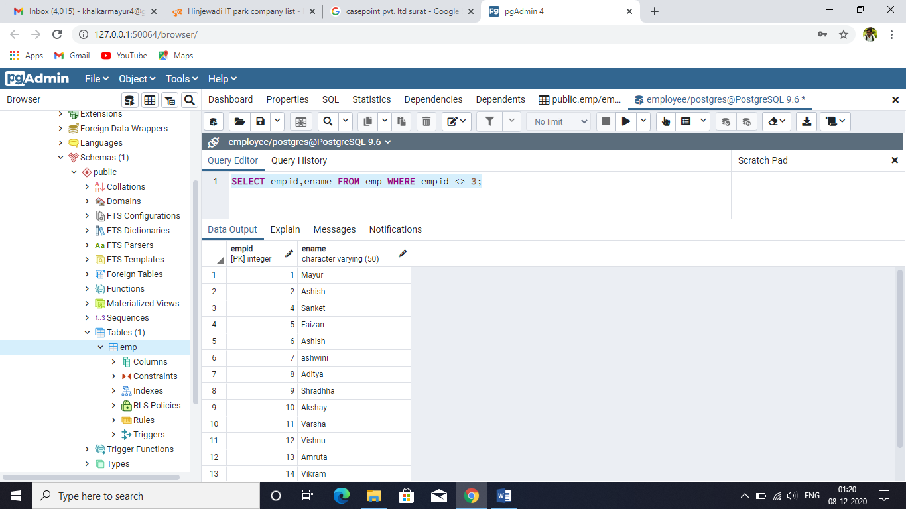

SELECT empid FROM emp WHERE CAST ( hiredate AS DATE )='19/10/1998'; 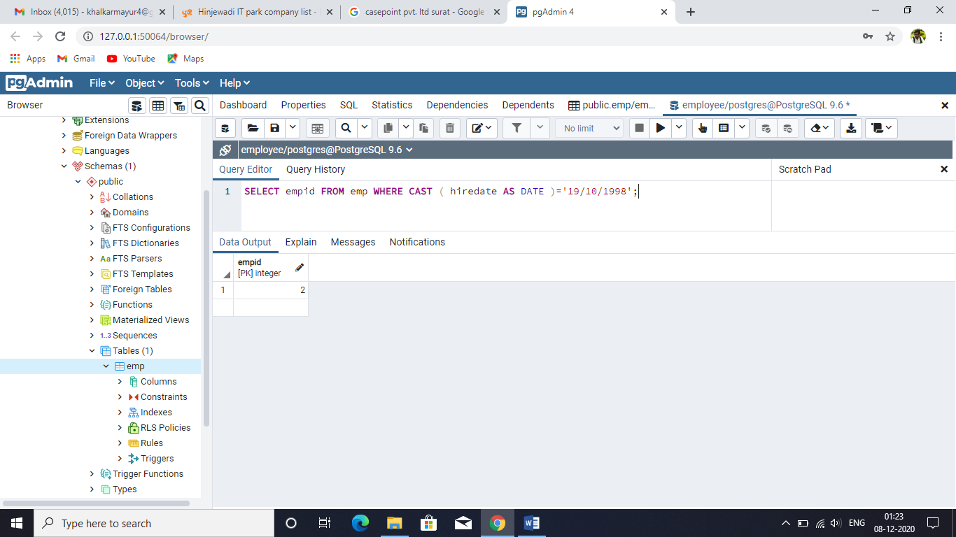

SELECT empid,ename from emp WHERE empid

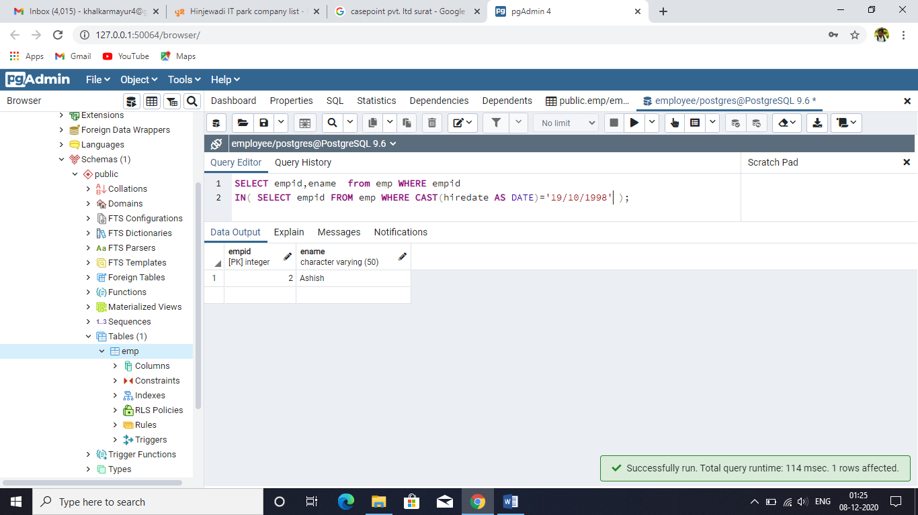IN( SELECT empid FROM emp WHERE CAST(hiredate AS DATE)='19/10/1998' );

SELECT empid , ename FROM emp WHERE sal BETWEEN 2000 and 3000; 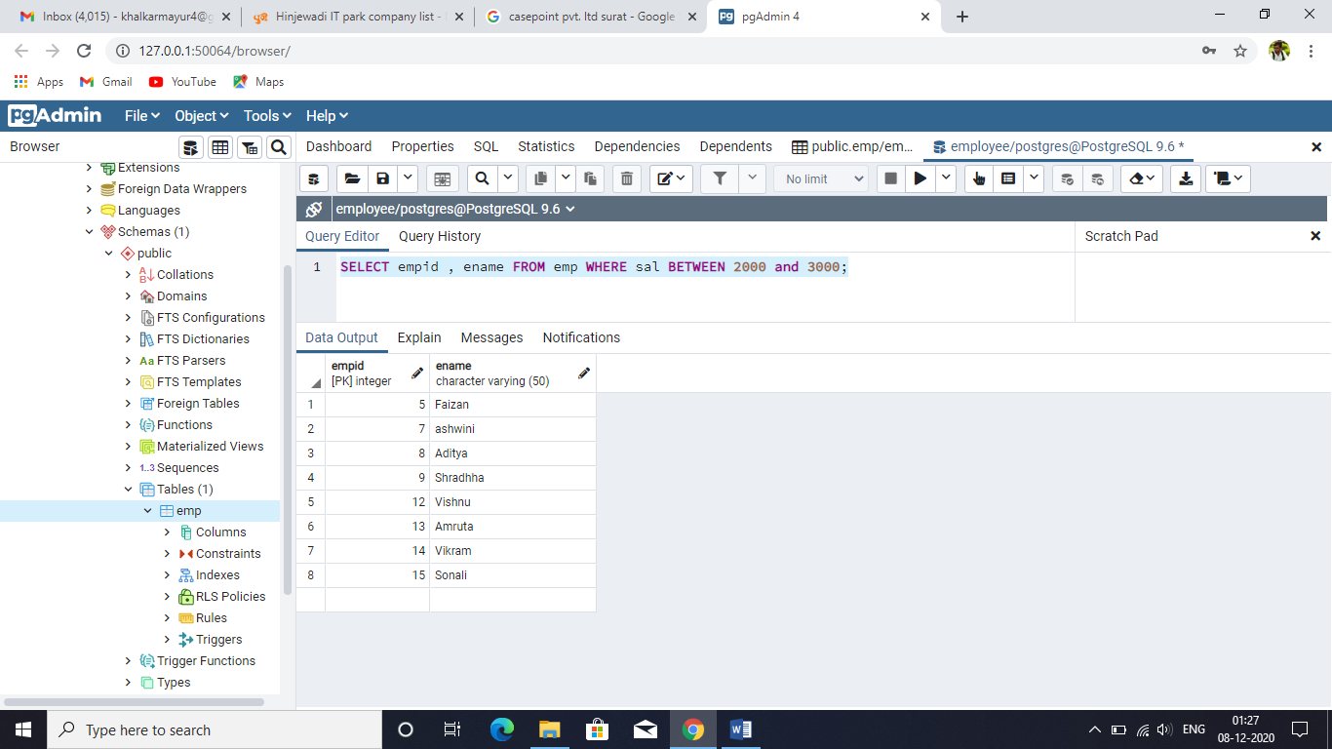

SELECT empid , ename FROM emp WHERE sal NOT BETWEEN 2000 and 3000;

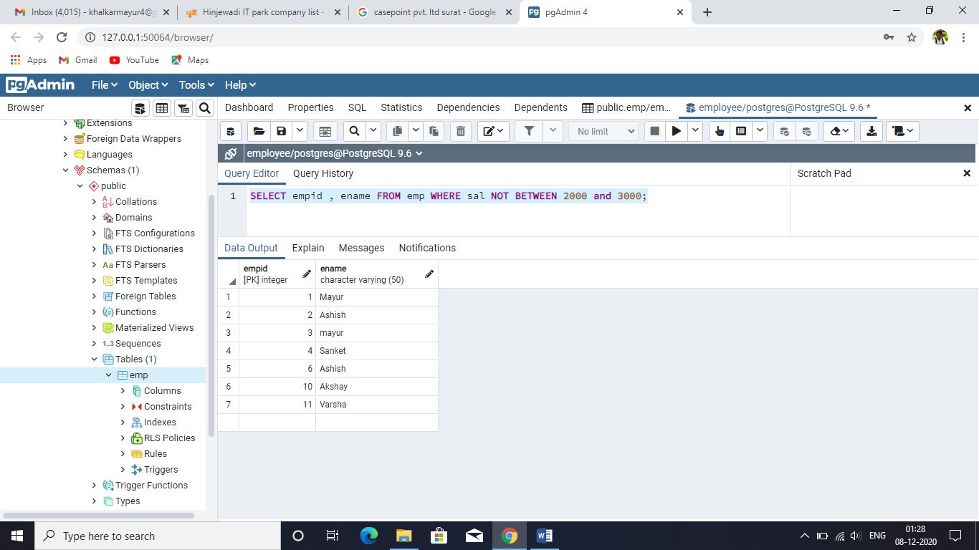

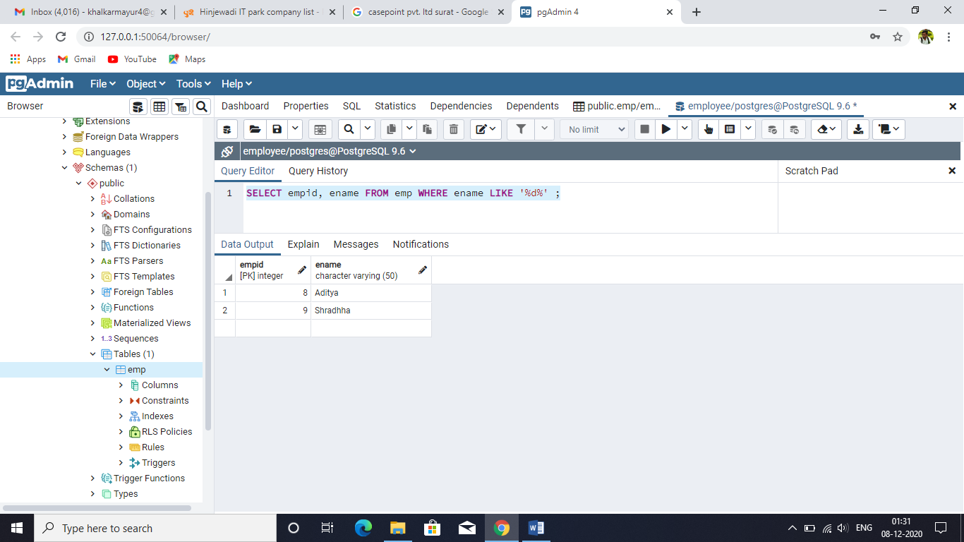SELECT empid, ename FROM emp WHERE ename LIKE '%d%' ;

SELECT empid, ename FROM emp WHERE ename LIKE 'M%' ;

